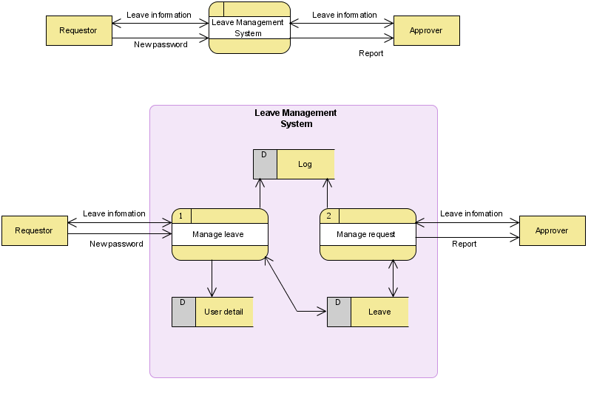**DFD**

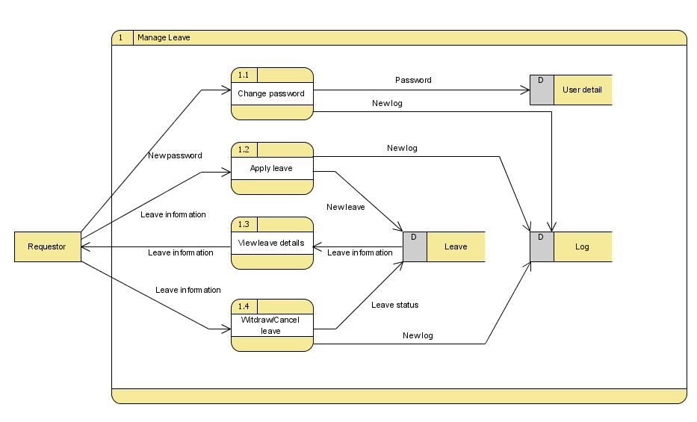

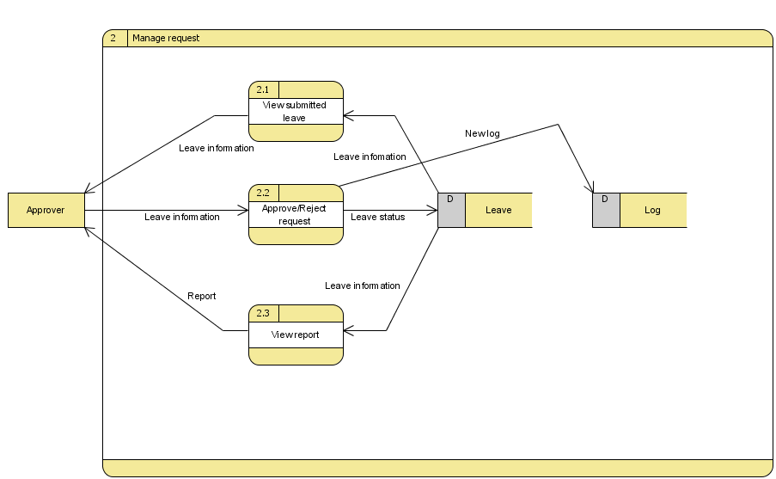

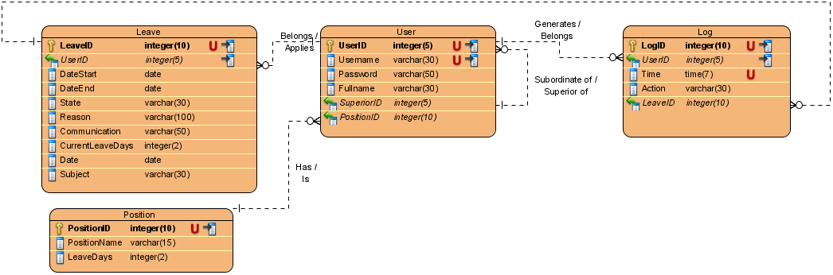**ERD**

Database: LeaveManagementSystem

Tables Summary: Leave, User, Log, Position

Table Details:

|  |  |  |  |  |
| --- | --- | --- | --- | --- |
| Leave | | | | |
| Name | DataType | Constraints | Nullable | Comment |
| LeaveID | integer(10) | PKUnique | No | Auto increment |
| UserID | integer(5) | FK (User.UserID) | No | Leave’s owner |
| DateStart | date |  | No |  |
| DateEnd | date |  | No |  |
| State | integer(2) |  | No | State of leave |
| Subject | varchar(30) |  | No |  |
| Reason | varchar(100) |  | No |  |
| Communication | varchar(50) |  | No | How to contact |
| CurrentLeaveDays | integer(2) |  | No | Leave policy may change in future so this field is used to review leave in past |
| Date | date |  | No | Day when applying leave |

|  |  |  |  |  |
| --- | --- | --- | --- | --- |
| User | | | | |
| Name | DataType | Constraints | Nullable | Comment |
| UserID | integer(5) | PKUnique | No | Auto increment |
| Username | varchar(30) | Unique | No |  |
| Password | varchar(50) |  | No |  |
| Fullname | varchar(30) |  | No |  |
| SuperiorID | integer(5) | FK (User.UserID) | No |  |
| PositionID | integer(10) | FK (Position.PositionID) | No |  |
| Log | | | | |
| Name | DataType | Constraints | Nullable | Comment |
| LogID | integer(10) | PKUnique | No | Auto increment |
| UserID | integer(5) | FK (User.UserID) | No |  |
| Time | time(7) | Unique | No |  |
| Action | varchar(30) |  | No |  |
| LeaveID | integer(10) | FK (Leave.LeaveID) | Yes | For leave-related action |

|  |  |  |  |  |
| --- | --- | --- | --- | --- |
| Position | | | | |
| Name | DataType | Constraints | Nullable | Comment |
| PositionID | integer(10) | PKUnique | No |  |
| PositionName | varchar(15) |  | No |  |
| LeaveDays | integer(2) |  | No |  |